**CST325 HW 1.3 – Vector Details**

(69 possible points weighted to 100)

1. Two vectors are considered the same if and only if they have the same: (1pt)
   * 1. Placement in the Cartesian Plane
     2. Magnitude
     3. Direction
     4. b. and c.
     5. All of the above
2. Which of the following about vectors and points are true? (2pts)
   * 1. A point is a displacement from the origin in a specific reference frame
     2. A vector is a displacement from the origin in a specific reference frame
     3. A point has meaning independent from any reference frame
     4. A vector has meaning independent from the origin

b and d are true.

1. True / False (1pt each)
   * 1. Vector addition is commutative TRUE
     2. Vector addition is associative TRUE
     3. Vector subtraction is commutative FALSE
     4. Vector subtraction is associative FALSE
     5. Vector-scalar multiplication is commutative TRUE
     6. The dot product is commutative TRUE
     7. The dot product is associative FALSE
     8. The cross product is commutative FALSE
     9. The cross product is associative FALSE
2. The result of multiplying a scalar and a vector is (1pt)
   * 1. A scalar
     2. A vector
     3. Something else
3. Given and , accurately draw the following: (3pts)

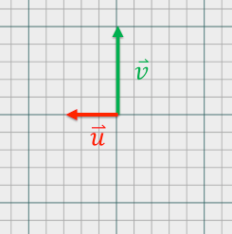







1. Given , , and : accurately draw the following: (3pts)

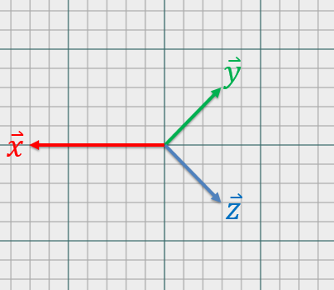



|  |  |  |
| --- | --- | --- |
|  | **x** | **y** |
|  | -7 | 0 |
|  | 3 | 3 |
|  | 3 | -3 |
|  | **-1** | **0** |



|  |  |  |
| --- | --- | --- |
|  | **x** | **y** |
|  | -7 | 0 |
| - | -3 | -3 |
|  | 3 | -3 |
|  | **-7** | **-6** |



|  |  |  |
| --- | --- | --- |
|  | **x** | **y** |
|  | 7 | 0 |
|  | 3 | 3 |
|  | -3 | 3 |
|  | **7** | **6** |

1. Express as a linear combination of **either** and ( **or** and (. Assume the tip of lies exactly ½ of the way between the tips of and . (5pts)

**= 3/2 + ½ (**



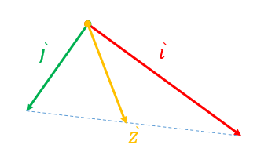

1. What vector operation is directly associated with the Pythagorean Theorem? (1pt)
   * 1. Addition
     2. Dot Product
     3. Magnitude
     4. Cross Product
2. (True / False) A vector can have a negative magnitude. (1pt) **False**
3. What is the length of the vector ? (2pts)

**= = 7**

1. (True / False) A vector can have a magnitude of 0. (1pt) **True**
2. (True / False) All vectors can be normalized. (1pt) FALSE (Magnitude = 0)
3. When is the following statement true? (Try comparing the lengths of different combinations of vectors. Is there anything significant about the angle between the two?). (3pts)

When the angle is 0. Then the magnitude of the sum of the vectors is also the sum of each vectors original magnitude.

1. A normalized vector is also called (1pt)
   * 1. a normal
     2. a normal vector
     3. a unit vector
     4. colinear
2. If a vector = (ax, ay, az) and has length 10 then what are the component values of the normalized version? (3pts)

ax/10, ay/10, az/10

1. Normalizing the vector (1, 2, 12) yields (2pts)
   * 1. (1, 2, 12)
     2. (1, 1, 1)
     3. (0.082, 0.164, 0.983)
     4. (0.1, 0.2, 0.7)
     5. (0.042, 0.130, 0.83)
2. How would you generate a random vector (3d) whose tip lied on the surface of a sphere with radius r (assume the tail is placed at the center of the sphere)? (5pts)

You can take 3 random numbers, as long as none of them are 0. You would then normalize them to a magnitude of 1. You would then multiply each of the vector components by r.

This will give you a new 3d vector with magnitude r, so its tip would be touching the sphere.

1. If two vectors are orthogonal, that means the angle between them is: (1pt)
2. 90 deg
3. PI / 2
4. PI
5. 180 deg
6. a. and b.
7. The dot product is a type of vector multiplication (product) that operates on two vectors (input) and generates the following as output: (1pt)
   * 1. A scalar value
     2. A vector value
     3. A unit vector
8. If two vectors and are orthogonal, what is the value of their dot product ()? (1pt) **0**
9. If two vectors and are equal, what is the value of their dot product ()? (1pt) **The square of either vector’s magnitude.**
10. If two vectors and are equal, what is the value of their dot product ()? (Pay attention to the hat.) (1pt) **1**
11. If two vectors and are opposite in direction but equal in magnitude, what is the value of their dot product ()? (Note: these are not unit vectors) (3pts) -**1**
12. Given two vectors and where = (ax, ay, az) and = (bx, by, bz), what is ? (Express your answer **without** using cosine) (2pts)
13. What is the dot product between (5, -2, 3) and (-2, 4, 6)? (1pt) **0**
14. When is the dot product of two vectors equal to the cos of the angle between them? In other words, when does ? (3pts)

**When are normalized.**

**Since both of their magnitudes will be 1and u · v = |u| |v| cos θ**

1. Given the dot product d of two vectors. What is the angle (in radians, not degrees) between the vectors used to generate the dot product? ( (3pts)

**𝜃 = cos−1 ( ∙ 𝐯 / |𝐮||𝐯| )**

1. The cross product is a type of vector multiplication (product) that operates on two vectors (input) and generates the following as output: (1pt)
   * 1. A scalar value
     2. A vector value
     3. A unit vector
2. The cross product between (1, 0, 0) and (0, 1, 0) is (2pts)
   * 1. 10
     2. 11
     3. (30, -29, -56)
     4. (0, 0, 1)
     5. (-56, -29, 30)
     6. (0, 0, -1)
3. The cross product between (-2, 13, 8) and (4, 2, -1) is (2pts)
   * 1. 10
     2. 11
     3. (30, -29, -56)
     4. (30, -56, -29)
     5. (-56, -29, 30)
     6. (-29, 30, -56)
4. What is the result of ? (1pt) **0**
5. What is the result of ? (1pt) **0**
6. What is the result of ? (Visual aids recommended… First think about the result of the cross product and then what happens with a dot product.) (2pts) **0**
7. What is the result of ? (2pts) **0**
8. (True / False) If (2pts) **True**
9. (True / False) If (2pts) **False**
10. (True / False) = (1pt) **TRUE**

Bonus

* 1. Derive the formula for the dot product using the Law of Cosines. (5pts)

